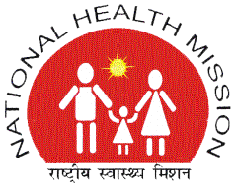 | NATIONAL HEALTH MISSION  STATE PROGRAM MANAGEMENT UNIT  19A, VISHAL COMPLEX, VIDHAN SABHA MARG, LUCKNOW- 226001  TELEPHONE -0522-2237595/ Fax -2237390  Email- mdupnrhm@gmail.com | 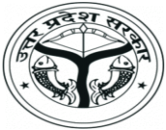

CORRIGENDUM NOTICE

This is with reference to the Tender for “Hiring of Agency for Research, Evaluation and Documentation of NHM Programmes”, published by The National Health Mission, Uttar Pradesh on 30/12/2016 via Tender notice No.8607 dared 29.12.2016.
NHM is considering the changes as suggested by probable Bidders participated in pre-bid meeting held on 10.01.2017 and a revised RFP shall be published very soon. Hence the current stated bid submission date i.e. on 03.02.2017 is being extended and a new bid submission date shall be published on NHM UP website soon with revised RFP.
Further updates regarding above tender can be accessed on the website: http://www.upnrhm.gov.in.
The decision of MD National Health Mission- UP shall be final. The MD-NHM-U.P. reserves the right to cancel or reject all or any Bid/Tender without assigning any reason.

S/d
(Alok Kumar)
Mission Director

